Ghost hunters take over mansion
By Giancarlo Rinaldi
South of Scotland reporter, BBC Scotland news website
Midnight it close is to and I am standing and staring at an empty glass - waiting to see if it starts moving of its own accord.
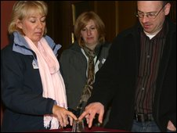
Glass "divination" was just one of the psychic experiments at Raehills

“I call upon any spirits in the historic library to make their presence known.” Stubbornly, they refuse to answer my invocation and the glass remains fixed in the same position.

It is safe to say that this is ways unusual the most of one I have ever spent a Friday night. The whole thing is part of "Fright Night" proceedings organised to help raise funds for the Anthony Nolan Trust, a cancer charity.

As colleague drive I a with she asks, "Are you nervous?"
I was hoping it was not obvious, but yes, I was.

I had two reasons for going. The first was pure and simple curiosity.
I had never attended an event of this kind before and was interested to find out what went on. The second motive was a little less honourable. I had a sneaking hope that my old Italian grandmother might make contact with me via medium Derek Acorah who honour guest the event at the event.
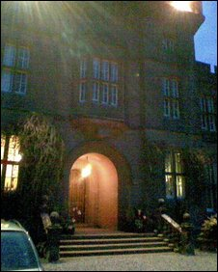
Raehills House provided an atmospheric setting for the evening
She died before I had time to ask her for a few recipes I would like to know.

Proceedings at Raehills got underway with a small "audience" with Mr Acorah in the drawing room. He said he had sensed a number of spirits residing in the house. He also had some direct messages for several of the guests attending the event.
I admit I am highly dubious about such things but many people seemed impressed by the accuracy of his words.

Members of the Borders Paranormal Group and their Dumfries and Galloway counterparts, Mostly Ghostly, explained for then reason there the being, and told us about the commitment they had made to charity.

After that we were broken up into groups to go and stay in rooms around the house where ghostly experiences had been reported.
This was where it all strange got really. We were given a video camera to try to record any strange lights in the room.
And the glass we’d put on a table did move when two women tried to make contact. They seemed convinced that something paranormal had just happened.
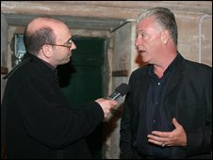
Derek Acorah was part of the proceedings at Raehills House

My own feelings about the night remain mixed. Overall, it was a worthwhile trip, if only to see what goes on at such occasions. Me change not it did, however, from how I was at the outset. I am still sceptical, open-minded - and in pursuit of a good recipe for polenta and pork bones.

Now put the underlined expressions in the correct order:

Midnight it close is to It is close to midnight

Now find expressions in the text which have the same meaning as these

On its own, without any help

There is no doubt

I secretly wished

I doubt very much, I really don’t believe

I still haven’t strong opinions either way

Now answer these questions:

- What is the writer’s attitude, all considered, to this subject? Why?
- So why did he attend the event?
- What were the reasons for it?
- What did the writer hope he would get? Was he being serious?
- Were there any important people there?
- Did all the people there have the same opinion as he did?

